**Queensborough Community College**

The City University of New York

**Department of Engineering Technology**

**ET 110 – Introduction to Circuit Analysis Laboratory**

**Lab#4**

**Mutism Electronic Simulation Software**

**Inspector: Prof. Wu**

**Date 9/16/16**

**Student Name: XIN SHEN**

* **State the objectives of this lab exercise**
* Introduction the circuit simulation software
* Learn how to use the software to build a circuit
* Learn how to measure the current and voltage in the circuit by circuit simulation software
* **Experimental**
* Part 2: current measurement in a series circuit

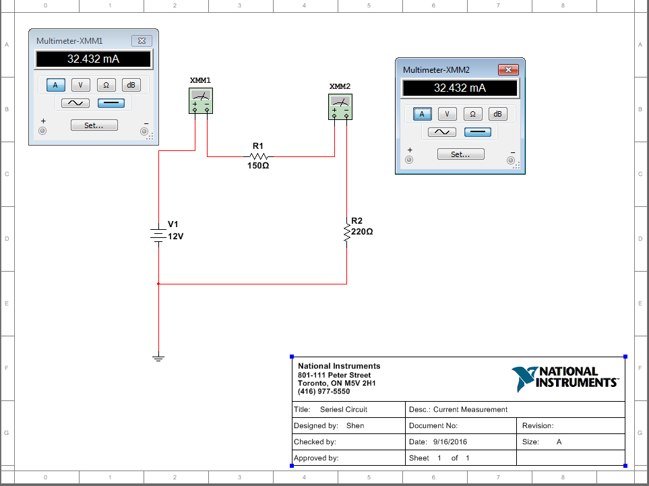

**Table 4.1**

|  |  |  |
| --- | --- | --- |
| $$V_{INPUT}$$ | $$I_{R1}$$ | $$I_{R2}$$ |
| $$V_{1}=12V$$ | **32.432mA** | **32.432mA** |
| $$V_{2}=15V$$ | **40.541mA** | **40.541mA** |

* Part 3: voltage measurement in a series circuit

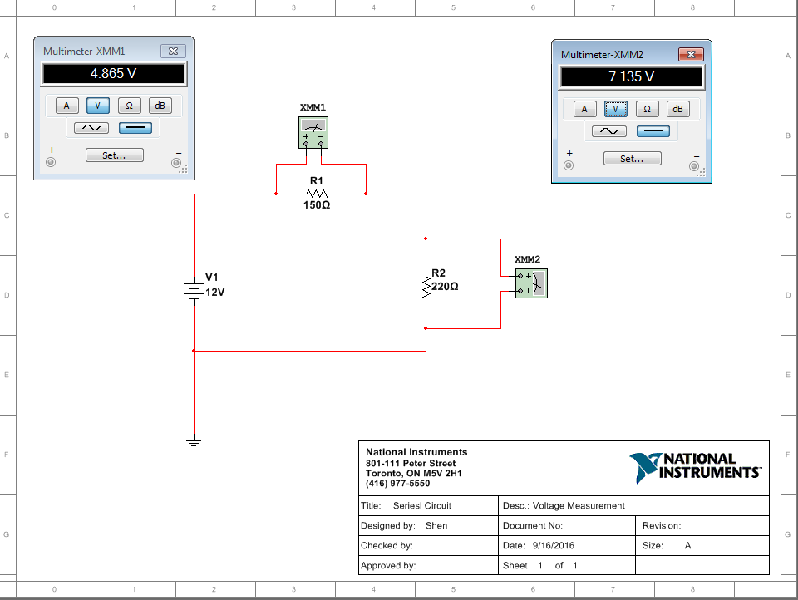

**Table 4.2**

|  |  |  |  |
| --- | --- | --- | --- |
| $$V_{input}$$ | $$V_{R1}(simulated)$$ | $$V_{R2}(simulated)$$ | $$V_{R1}+V_{R2}=(calculated)$$ |
| $$V_{1}=12V$$ | **4.865V** | **7.135V** | **12V** |
| $$V_{2}=15V$$ | **6.081V** | **8.919V** | **15V** |

* Part 4: voltage measurement in a series-parallel circuit

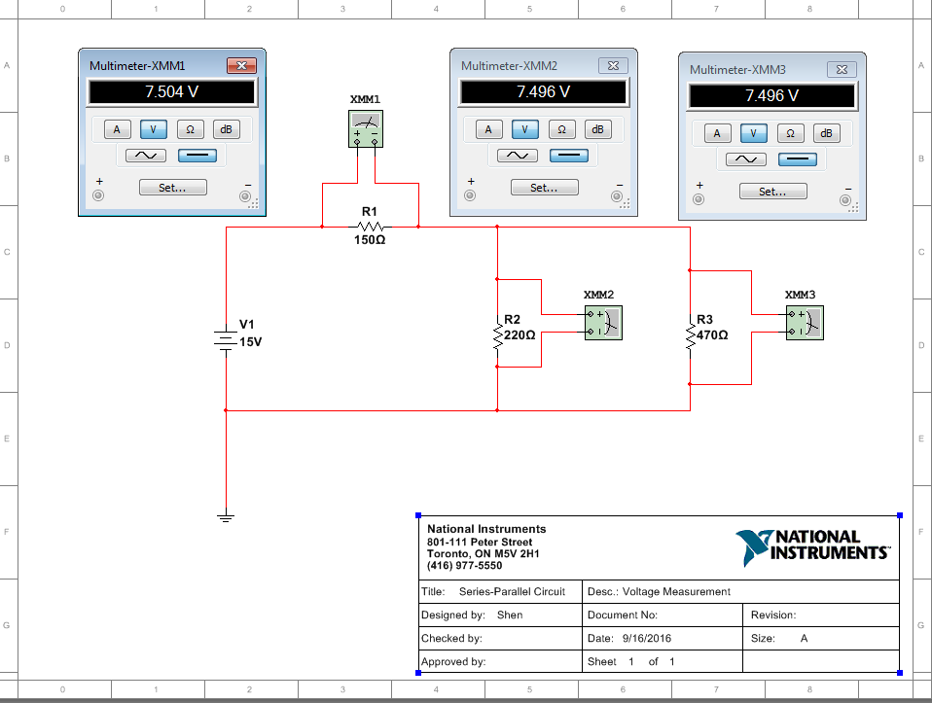

**Table 4.3**

|  |  |  |  |  |
| --- | --- | --- | --- | --- |
| $$V_{input}$$ | $$V_{R1}$$ | $$V_{R2}$$ | $$V_{R3}$$ | $$V_{R1}+V_{R2}=$$ |
| $$V_{1}=12V$$ | **6.003V** | **5.997V** | **5.997V** | **12V** |

**Table 4.4**

|  |  |  |  |  |
| --- | --- | --- | --- | --- |
| $$V_{input}$$ | $$V_{R1}$$ | $$V_{R2}$$ | $$V_{R3}$$ | $$V_{R1}+V_{R2}=$$ |
| $$V_{2}=15V$$ | **7.504V** | **7.496V** | **7.496V** | **15V** |

* Part 5: current measurements in a series-parallel circuit

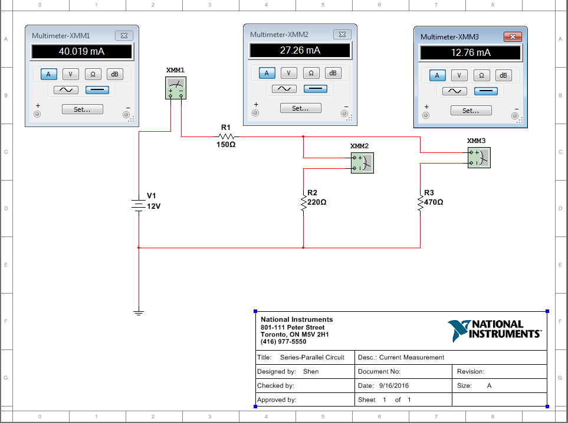

**Table 4.5**

|  |  |  |  |  |
| --- | --- | --- | --- | --- |
| $$V_{input}$$ | $$I_{R1}$$ | $$I_{R2}$$ | $$I_{R3}$$ | $$I_{R2}+I_{R3}=$$ |
| $$V_{1}=12V$$ | **40.019mA** | **27.26mA** | **12.76mA** | **40.019mA** |
| $$V_{2}=15V$$ | **50.024mA** | **34.074mA** | **15.95mA** | **50.024mA** |

* **Conclusion**

It was a fun experience to use a circuit simulation software to create the series circuit or the series-parallel circuit. Basically, it looks like you drawing the circuit on the graphing paper. In my personal sense, the component toolbar is the most helpful and valuable to use when you start to create a circuit. Because it saves time and more easy to find the components what you need. In fact, you don’t need to look for the groups and families before you can reach the component you really need. The instruments toolbar gives you all the meter you need when you are going to measure one objective in the circuit. However, before you can get the measurement results, you need to know how to connect the wires in the correct way. For example, when you measured the current and voltage, you used the same meter which was the multimeter. Nonetheless, you have to use a different method to obtain the result. For measuring the voltage, you just need link the both terminals to the multimeter. For current measurement, you need to break one of the terminals and let the multimeter join the circuit’s cycle.

So after all of them, you able to design a simple series or series-parallel circuit and predict the voltage and current on it.